Directions to Stanford

From Highway 101 North & South
Exit onto Embarcadero Road and travel west, following the signs directing you to Stanford University. About three miles after you exit the freeway, Embarcadero Road becomes Galvez Street as you cross El Camino Real. Turn right into the Galvez Lot.

From Highway 280 North & South
Exit onto Sand Hill Road and follow the signs for Stanford University. Heading east, drive approximately 3 miles to the Stanford Shopping Center. Turn right onto Arboretum Road (Nordstrom is on your right). Stay on Arboretum until it ends, then turn right onto Galvez Street. Turn into the Galvez Lot.
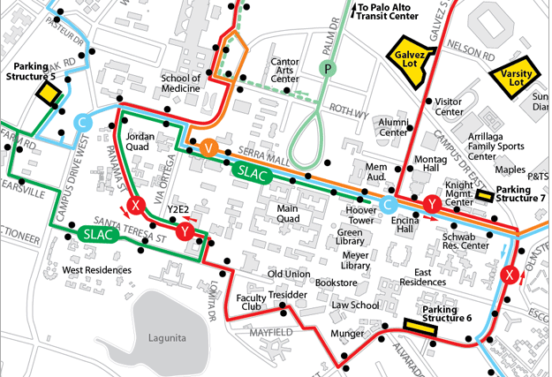

Parking at the Galvez Lot
At the parking machine, enter the space number in which you parked. Enter coupon number 7279 to discount the parking to $8 for the day. It will print a receipt which you can keep. Continue walking up Galvez Street to the Margarita bus stop at Galvez and Serra Street (a red “Y’ on the map). From here, it may take 45 minutes to reach the Workshop by shuttle. Take the bus to Panama and Via Ortega Street (near a red Y on the map) and walk to Huang Engineering Center at 475 Via Ortega. The workshop is in the MacKenzie Room (Huang 300) on the third floor.

